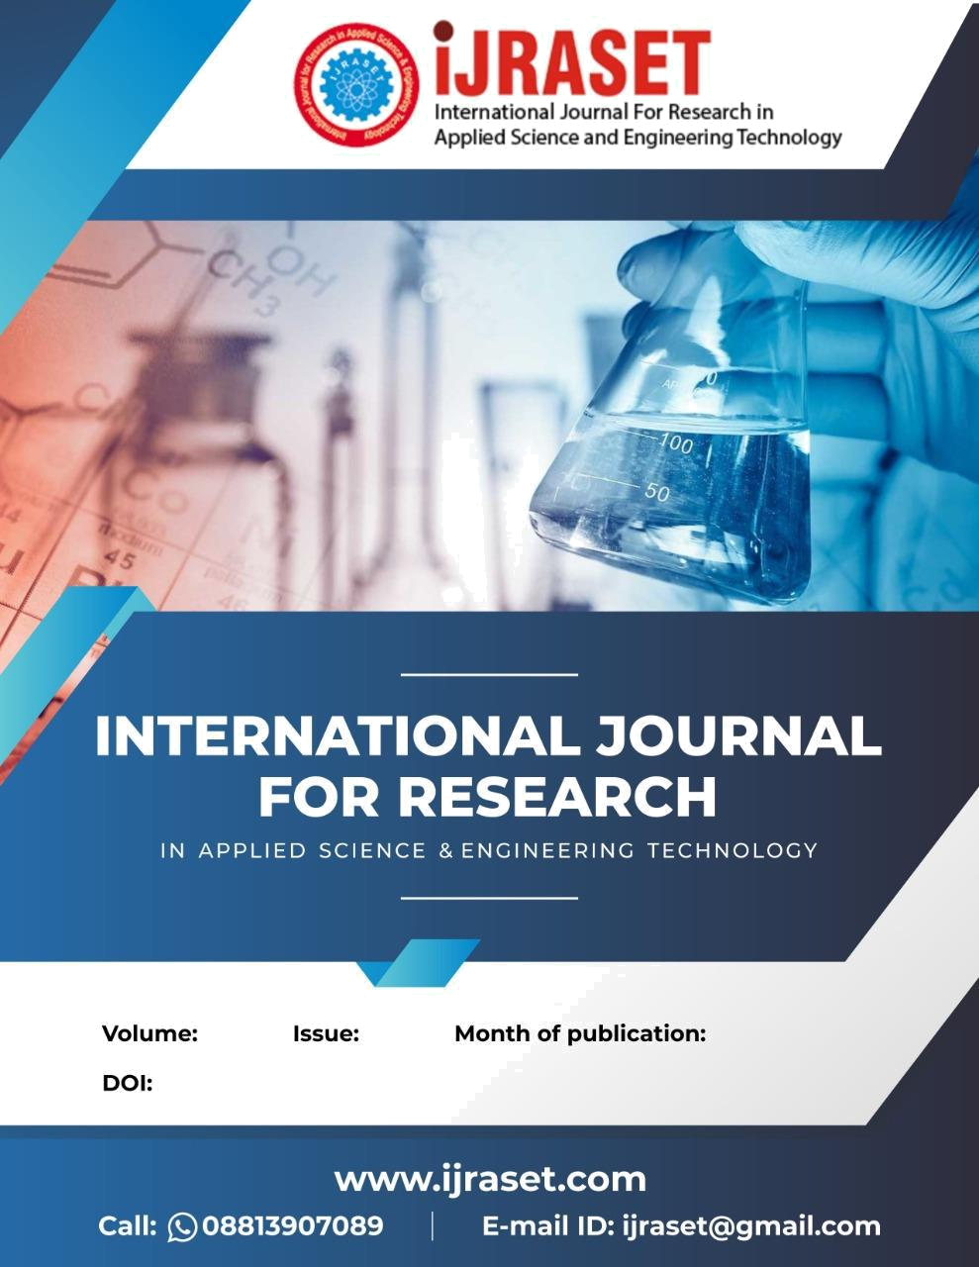

9 V May 2021

https://doi.org/10.22214/ijraset.2021.34754

International Journal for Research in Applied Science & Engineering Technology (IJRASET)

ISSN: 2321-9653; IC Value: 45.98; SJ Impact Factor: 7.429

Volume 9 Issue V May 2021- Available at www.ijraset.com

Food Wastage Reduction by Donation to Charity Institutions

Maheswari M¹, Meena K², Shanmathi S³, Shopica V⁴

¹Assistant Professor, ^{2, 3, 4}UG Scholar, Department of Computer Science and Engineering, Panimalar Engineering College, Chennai.

Abstract: A generous mobile application to alleviate the burden of innocent people, who need food to survive. At the same time, the application also helps to reduce the problem of food waste. Although there are a few mobile applications for help, none of them provide communication between the needy, donors, and food suppliers to solve the food wastage problem. This app provides comparative research between many charitable applications that help the community, defines the app limit, and introduces a mobile charity app.
The results of the feasibility study showed that the system is easy to use and is able to reduce 49% of food waste in the selected testing area. The program will create a standard working portal for hotels/restaurants and charities. The charity can directly contact restaurants with leftover food and a report will be generated that will show how much food is being served by which restaurant and give them reward points. Administrator, Third-party, and premium user are advanced modules. Food Donor can be any organization, institution, or college that wants to donate food and make a new food donation request. Food recipients can be any food aid company looking for food.

A new food donation request will be created on the portal and once the application has approved the request, a notice will be sent to the third-party responsible for delivering the food from the food supplier to the food recipient. Premium users are the ones who donate food on an everyday basis.

Keywords: Mobile charity application, Food Donor, Food Receiver, Donation

- INTRODUCTION

In an area where many people suffer from malnutrition, food wastage is a disturbing problem. Roads, garbage cans, and garbage dumps provide ample evidence of this. Weddings, carnivals, restaurants, community, and family functions produce so much food. But food shortage still a problem in many areas.

Food shortage indicates many economic problems. A high standard of living has led to wastage of food, clothing, etc.. because of the rapid changes in habits and lifestyle. Instead of wasting these resources, we can use them to donate them to various organizations such as orphanages, old age homes, etc.

The product is a web-based application that aims to establish links between donors like restaurants, etc.. and charity organizations that are in need of food. Feed the needy is an online-based app that provides a platform for donors with leftover food to donate to all organizations in need of food.

- LITERATURE SURVEY

- Food Donation Portal

The paper Food donation portal, which was published in 2015 summaries in brief the evolution of food donation activities and offers a medium that connects donors with NGOs. An idea for a food donation network is presented and impact on society through this medium is mentioned. The disadvantage in this paper is that there is no GPS service available. That means the system does not allow the organization or charity to find the nearest donor available in the area and they have to manually find the donors.

- Helping Hands

The paper Helping Hands, published in 2016, a new internet-based application that provides a platform for donating old stuff and leftover food to all needy people/organizations. It provides information about the motivation to come up with such an application, thereby describing the existing donation system and how the proposed product works for the betterment of society. The disadvantage of this project is that there is no dashboard available that is, at the end of the month the system don’t get all the records that how much is donated or received by the receiver.

©IJRASET: All Rights are Reserved | 2036

International Journal for Research in Applied Science & Engineering Technology (IJRASET)

ISSN: 2321-9653; IC Value: 45.98; SJ Impact Factor: 7.429

Volume 9 Issue V May 2021- Available at www.ijraset.com

C. Beyond Food sharing: Supporting Food waste Reduction With ICT’s

The paper Beyond food sharing: Supporting food waste reduction With ICTs’, published in 2016, guaranteeing food security is key in improving the quality of life of citizens at all levels of society. The recent economic crisis has increased the number of people living in conditions of food poverty, especially in developed regions. Despite a growing awareness of the importance of reducing waste and managing food surplus, the role of ICTs in this domain is still unclear and rarely documented. This paper describes the use of ICT tools to recover food surplus at different stages of the supply chain and also describes the way forward for an integrated set of ICT tools to reduce waste from producers to households.

D. Food Donations Using a Forecasting-simulation Model

The paper Food donations using a forecasting-simulation model, published in 2016, presents a methodology to estimate donations for non-profit hunger relief organizations.

These organizations are committed to alleviating hunger around the world and depend mainly on the benevolence of donors to achieve their goals. However, the quantity and frequency of donations they receive varies considerably over time which presents a challenge in their fight to end hunger. A simulation model is developed to determine the expected quantity of food donations received per month in a multiware house distribution network.

The simulation model is based on a state-space model for exponential smoothing. A numerical study is performed using data from a non-profit hunger relief organization. The results show that good estimation accuracies can be achieved with this approach. Furthermore, non-profit hunger relief organizations can use the approach discussed in this paper to predict donations for proactive planning.

E. Smartphone Based Waste Food Supply Chain for Aurangabad City Using GIS Location Based and Google Web Services

The Paper Smartphone Based Waste Food Supply Chain for Aurangabad City Using GIS Location Based And Google Web Services, published in 2014, describes the client-server GIS and Smartphone application for the hunger free city. At the client side App provide facility to food to the charity for the help of hungry people. Donors enter basic information like latitude and long quantity of waste food and type of waste along with value and contact number. Charities can pick up that waste food and deliver food to hungers.

Completion of registration will placed onto server database where charities can store the entries of donor in table format and shows the optimal path between donor locations to nearest charity along with direction. So, wastage food can easily deliver to hungry people within a time.

F. Development of a Sustainable Food Supply Chain by Post Harvest Program

The paper Development of a Sustainable Food Supply Chain by Post Harvest Program introduces The Post Harvest Project (PHP), which is a group of committed technology and capital partners dedicated to delivering technological solutions to food waste in the supply chain. Of the many technological solutions being pursued by PHP, an innovative food preservation technology called nanoICE is described in detail.

An effort is underway in Ghana to build a series of small community food process plants based on improved cold storage on fishing boats and on-shore facilities for preserving fish, which in an important source of protein.

The aim of PHP's effort in Ghana is to engage local communities to feed people and create opportunities, and improve health through good nutrition.

- EXISTING SYSTEM

At present, the need of the system is completed using websites which aren't accessible quicker and supply no awareness about the service to the planet. there's no real interaction between the donor and recipient since everything disclosed by intermediates. one more reason includes there's no active mobile application available in locality.

IV. PROPOSED SYSTEM

The system will make sure that the surplus food from functions, restaurants, and hotels goes to the hungry people instead of being thrown away resulting in food wastage. The system will act as a communication platform between the Donor and the Recipient. In our system, the Donor and the recipient can locate each other easily.

©IJRASET: All Rights are Reserved | 2037
International Journal for Research in Applied Science & Engineering Technology (IJRASET)

ISSN: 2321-9653; IC Value: 45.98; SJ Impact Factor: 7.429

Volume 9 Issue V May 2021- Available at www.ijraset.com

- SYSTEM ARCHITECTURE
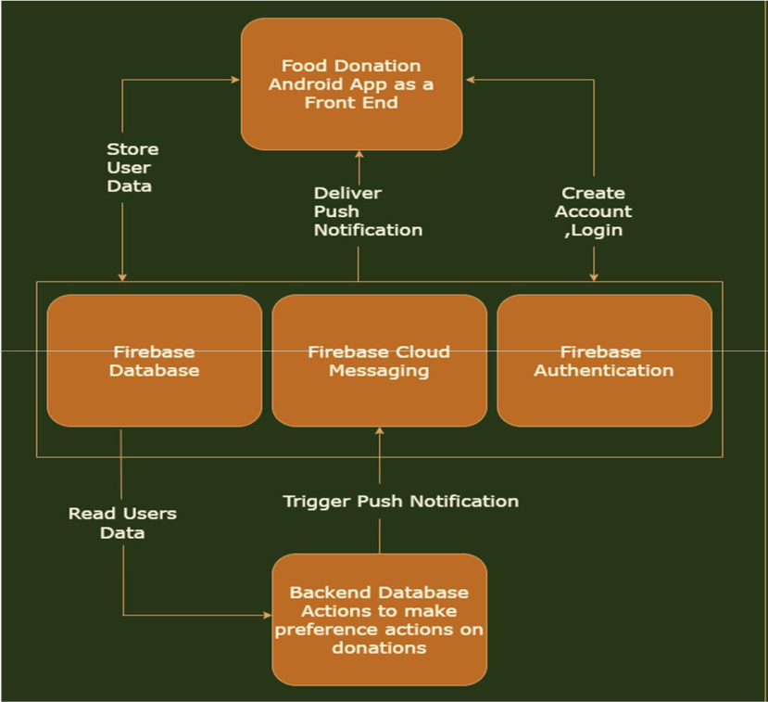

A system architecture is a conceptual model that defines the structure, behavior, and more views of a system. An architecture description is a formal description and representation of a system, organized in a way that supports reasoning about the structures and behaviors of the system .Here, the Android Studio with some functionalities of Java, CSS, and HTML is used as a front end with XML as a primary language. This is the module that happens to interact with that of the user to perform all the required GUI. The Firebase Realtime Database is a cloud-hosted database in which data is stored as JSON. The data is synchronized in real-time to every connected client.

VI. FUNCTIONALITIES

A. Login & Registration

This phase involves signing in and registering for both the donor and the recipient. The user’s details are maintained confidentially by maintaining a separate account for each user. At the same time, the admin can view the details of the registered agent.

B. Donor Module

In the donor module, the donor gives the leftover food to the orphanage. The donor gives the request to the admin for the purpose of collecting the leftover food. The donor can view the orphanage details.

C. Receiver Module

In the Receiver module, the Receiver maintains the orphanage details. It can also view the donor details. The Receiver gives the request to the admin for collecting the food from the donor. After collecting the food, the recipient gives the alert message to the donor.

VII. CONCLUSION

Thus, it's better understood how the proposed system is better than the prevailing system. The surplus food produced in functions, gatherings are often easily donated to the needy. Visualization of the impact of donation features a positive impact on the users. This is an attempt focused on feeding the hungry people and minimizing the food wastage problem at the same time. It will be compatible with everyone. In the existing system, there are many websites available that have an intermediary person between donor and recipient. Using this application the donor and recipient can communicate with each other directly. The Donor needs to send a request to the recipient. If they accept, food will be sent to them. This application is developed to avoid the food scarcity problem.

©IJRASET: All Rights are Reserved | 2038
International Journal for Research in Applied Science & Engineering Technology (IJRASET)

ISSN: 2321-9653; IC Value: 45.98; SJ Impact Factor: 7.429

Volume 9 Issue V May 2021- Available at www.ijraset.com

REFERENCES

- G. Rovati and L. Pesenti, “Food poverty, Food bank,” Aiutialimentari e inclusionesociale. Vita e Pensiero, Milano, 2015. [Online]. Available: http://www.vitaepensiero.it/scheda-libro/giancarlo-rovati-luca-pesenti/ food-poverty-food-bank-9788834329917-300632.html
- M. Schuster and M. Torero, “Reducing food loss and waste,” International Food Policy Research Institute (IFPRI), IFPRI book chapters, 2016. [Online]. Available: http://econpapers.repec.org/bookchap/fprifpric/9780896295827-03.htm
- P. Garrone, M. Melacini, and A. Perego, “Opening the black box of food waste reduction,” Food Policy, vol. 46, pp. 129–139, Jun. 2014. [Online]. Available: http://www.sciencedirect.com/science/article/ pii/S0306919214000542
- J. Gustavsson, C. Cederberg, U. Sonesson, R. Van Otterdijk, and A. Meybeck, “Global food losses and food waste,” Food and Agriculture Organization of the United Nations, Rom, 2011. [Online]. Available: http://www.madr.ro/docs/ind-alimentara/ risipaalimentara/presentation food waste.pdf
- A. Halloran, J. Clement, N. Kornum, C. Bucatariu, and J. Magid, “Addressing food waste reduction in Denmark,” Food Policy, vol. 49, Part 1, pp. 294–301, Dec. 2014. [Online]. Available: http://www.sciencedirect.com/science/article/pii/S0306919214001365
- . Ganglbauer, G. Fitzpatrick, O. Subasi, and F. Gueldenpfennig, “Think Globally, Act Locally: A Case Study of a Free Food Sharing Community and Social Networking,” in Proceedings of the 17th ACM Conference on Computer Supported Cooperative Work & Social Computing, ser. CSCW ’14. New York, NY, USA: ACM, 2014, pp. 911–921. [Online]. Available: http://doi.acm.org/10.1145/2531602.2531664
- C. Corbo and F. Fraticelli, “The use of web-based technology as an emerging option for food waste reduction,” in Envisioning a future without food waste and food poverty. Wageningen Academic Publishers, Oct. 2015, pp. 133–142. [Online]. Available: http://www.wageningenacademic.com/doi/abs/10.3920/978-90-8686-820-9 15

©IJRASET: All Rights are Reserved | 2039

